Hospital Payroll system

Design
Create the following classes to represent a Hospital payroll system.
Employee
-firstName: String
-lastName: String
-baseRate : double

(getters and setters for the above)
+ calculateWeeklySalary(hours : double )
+printAll()

.

Porter
site : String

(getters and setters for the above)
+printAll()

Surgeon
specialistArea : String
consultationFee : double

(getters and setters for the above)
+ calculateWeeklySalary(hours : double )
+printAll()
Pharmacist
grade : int
bonus : double

(getters and setters for the above)
+ calculateWeeklySalary(hours : double )
+printAll()

The implementation of the calculateWeeklySalary method for each employee type should be as defined below.

Employee type | Weekly Salary
Employee / Porter | Hours worked per week * base rate
Pharmacist | Hours worked per week * base rate + bonus
Surgeon | Hours worked per week * base rate + Consultation Fee

( Note : All employees work 35 hours in a week.)

Implementation

Create a class PayrollManager.java with the following constant (HOURS_PER_WEEK), static variable (employees) and methods. Note all methods are declared static.
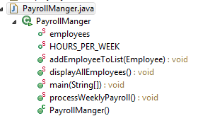
Set as 35

Within PayrollManager.java (main method) firstly create and populate the list of employees as an Array of type Employee – limited to six employees.

You should use polymorphic processing to manage the pay run processing (processWeeklyPayrol() )and display all functionality for the employees (displayAllEmployees() ). Use the test data listed in section 4.

For example when creating the employee types use something like this..
When adding an employee to the Array of employees ensure the array has capacity and has free space for it. To do this you should check if the proposed index location in the array is null. If so add it can be added otherwise you can’t add at this location.
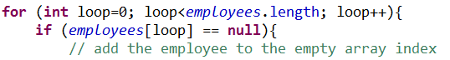

The processWeeklyPayroll() should be implemented something like this …
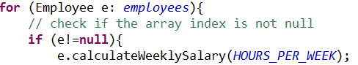
The displayAllEmployees() method should be implemented something like this …
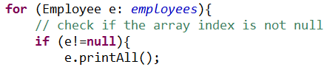

Test data :

Employee type | First Name | Last Name | Base rate | Attributes Specific to employee type
Employee | Odd | Jobbie | £10.50 | N/A
Porter | Ivana | Patient | £10.50 | Site: Royal
Porter | Amanda | Pushbed | £10.50 | Site: BCH
Surgeon | Jack | Ripper | £55.25 | Specialist Area : Renal Consultation Fee :£650.00
Surgeon | Edward | Lister | £55.25 | Specialist Area : Vascular Consultation Fee :£800.00
Pharmacist | Poppy | Pill | £30.50 | Grade: 7 Bonus : £750.00

Program output

The output of PayrollManager.java should be…
